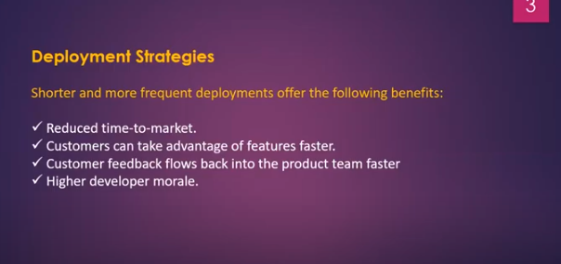

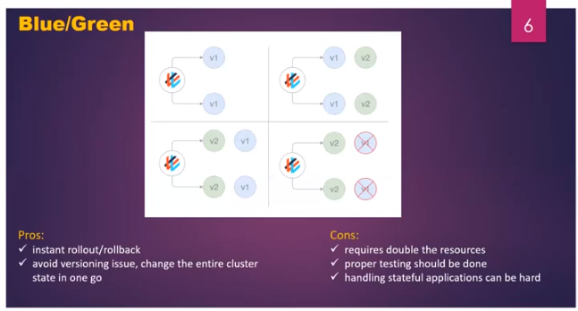

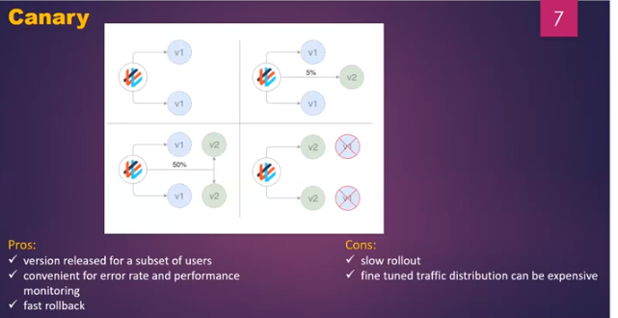

**Rolling Update and Roll out**

If changes happens in image, need to update the changes in the deployment file i.e is rolling update.

Roll out maintains the history of the all the revision versions. If any thing happens to the updated version, we can roll back to previous version.

No down time in Rolling update strategy. There is down time in recreate strategy

Blue-green deployment creates the separate instances for the v1 and v2. Vi is for end users and v2 is for testing.

**Kubernetes Architecture:**

Container orchestration automates the deployment, management, scaling, and networking of containers.

**What is container orchestration used for?**

Use container orchestration to automate and manage tasks such as:

* Provisioning and deployment
* Configuration and scheduling
* Resource allocation
* Container availability
* Scaling or removing containers based on balancing workloads across your infrastructure
* Load balancing and traffic routing
* Monitoring container health
* Configuring applications based on the container in which they will run
* Keeping interactions between containers secure

Kubernetes is a portable, extensible, open-source platform for managing containerized workloads and services, that facilitates both declarative configuration and automation. It has a large, rapidly growing ecosystem. Kubernetes services, support, and tools are widely available.

* When you deploy Kubernetes, you get a cluster. A cluster has a at least one worker node and at least one master node.
* There can be more than one master nodes in a cluster to provide a cluster with failover and high availability

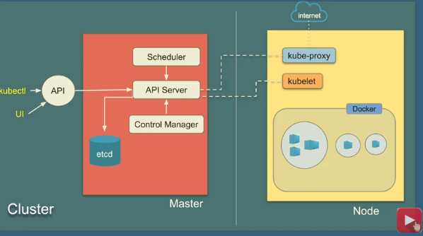

**Master:**

* Responsible for managing the cluster
* Monitors nodes & pods in a cluster
* When node fails, moves the workload of the failed node to another worker node.

1. **API server:** for all communications(json over HTTP API)

* API’s allow applications to comm’n with one another.
* It is front-end for the kubernetes control plane.
* Exposer API for almost every operation. The users, management devices, and command line interfaces all talk to the API server to interact with the Kubernetes cluster.

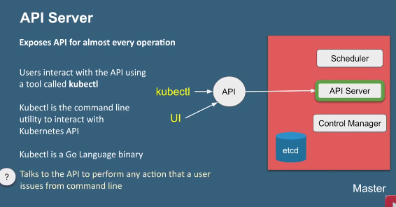

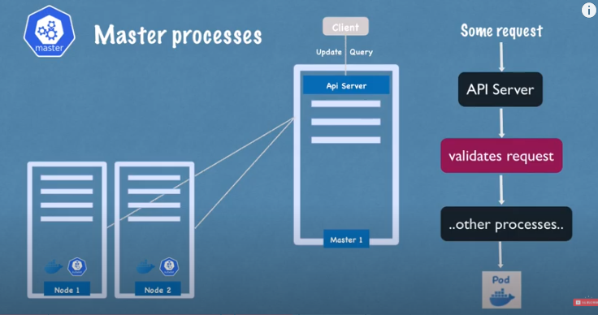

1. **Scheduler:** Schedules the pods on nodes. It gets the information from the config file which node the pods can be place.

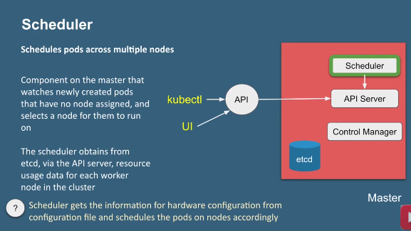

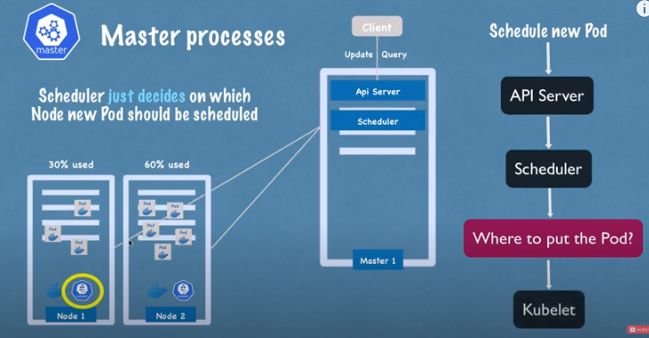

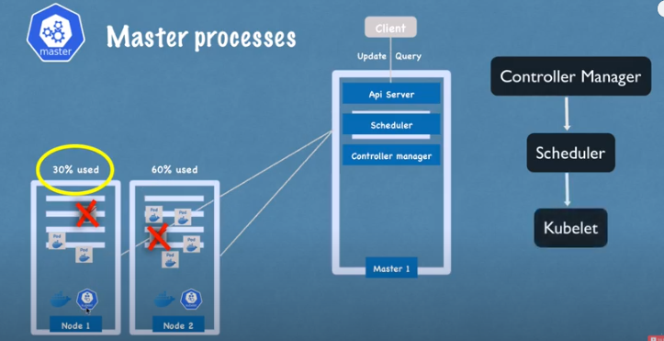

1. **Controller manager:**

**Kube-control-manager** runs controllers responsible to act when nodes become unavailable, to ensure pod counts are expected, to create endpoints, service accounts, and API access tokens.

1. **Node controller:** Responsible for noticing and responding when nodes go down.
2. **Replication controller:** Responsible for maintaining the correct number of pods for every replication controller object in the system.(correct no.of pods as per the configuration file)
3. **Endpoint controller:** responsible for the all services and comm’n (that is joins service & pods)
4. **Service account and token controllers:** Responsible for create default accounts and API access tokens for new namespaces.

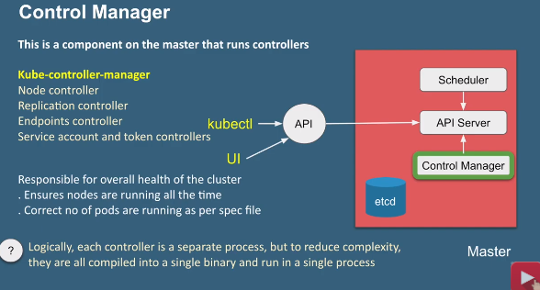

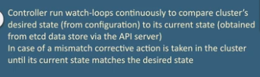

**cloud-control-manager**

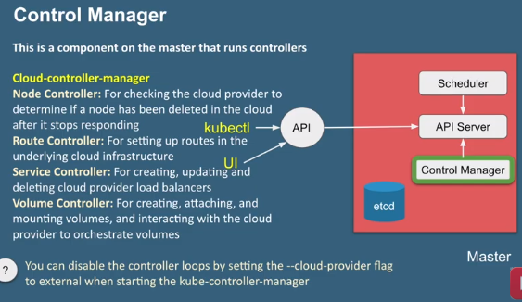

**Etcd:** open source, Distributed key-value database from coreOS

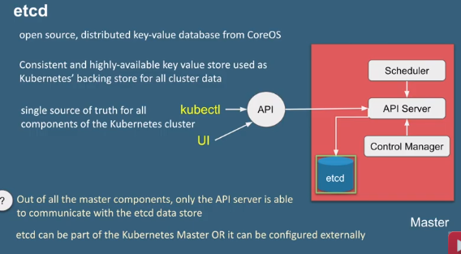

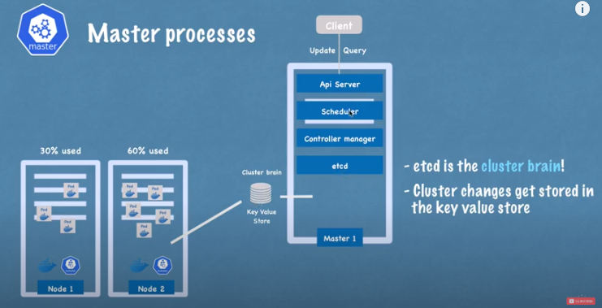

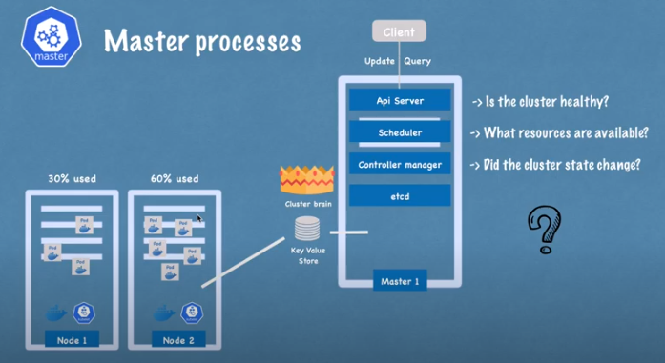

**Node:**

Kubelet interacts with the both-Container and Node

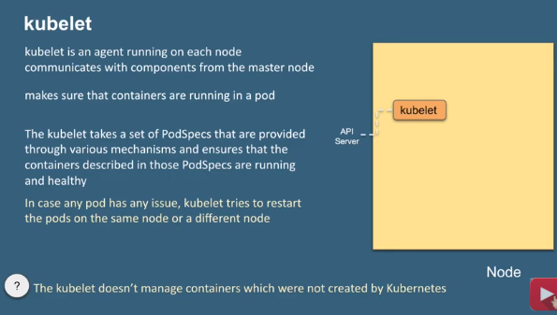

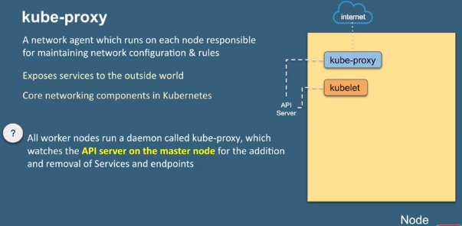

It is **responsible** for routing traffic to the appropriate container based on IP and port number of the incoming request.

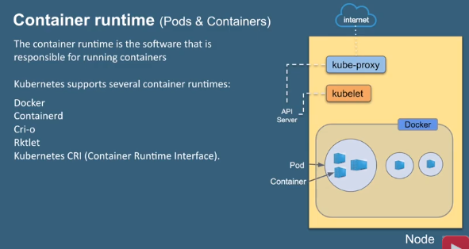

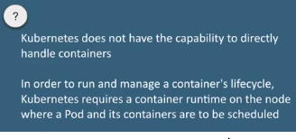

**Kubernetes Components:**

**Pod:**

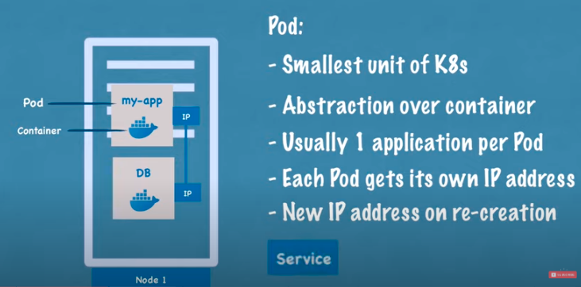

**Service:**

Service is also a Load balancer

**Service** enables network access to a set of Pods in Kubernetes. Services select Pods based on their labels. When a network request is made to the service, it selects all Pods in the cluster matching the service's selector, chooses one of them, and forwards the network request to it. In this lab you can explore different types of services.

Kubernetes Service Types allow you to specify what kind of Service you want. The default is Cluster IP.

* **Cluster IP:** Exposes the Service on a cluster-internal IP. Choosing this value makes the Service only reachable from within the cluster. This is the default Service Type.
* [**NodePort**](https://kubernetes.io/docs/concepts/services-networking/service/#nodeport)**:** Exposes the Service on each Node's IP at a static port (the NodePort). A Cluster IP Service, to which the NodePort Service routes, is automatically created. You'll be able to contact the NodePort Service, from outside the cluster, by requesting <NodeIP>:<NodePort>.
* [**LoadBalancer**](https://kubernetes.io/docs/concepts/services-networking/service/#loadbalancer)**:** Exposes the Service externally using a cloud provider's load balancer. NodePort and ClusterIP Services, to which the external load balancer routes, are automatically created.

[**ExternalName**](https://kubernetes.io/docs/concepts/services-networking/service/#externalname)**:** Maps the Service to the contents of the externalName field (e.g. foo.bar.example.com), by returning a CNAME record

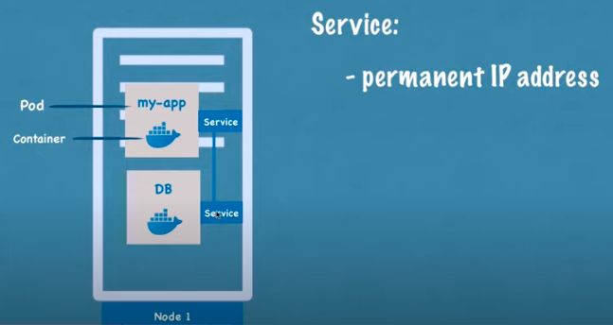

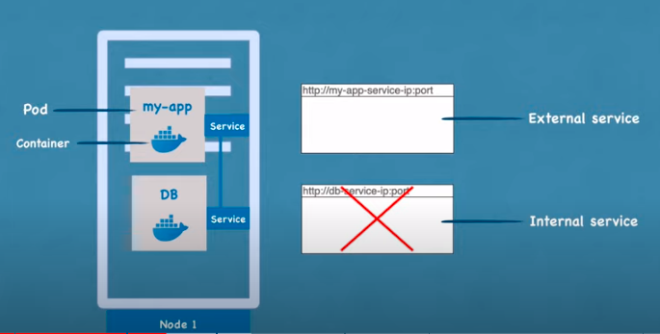

If just database url changed, you need to do all below things. So configmaps comes under picture.

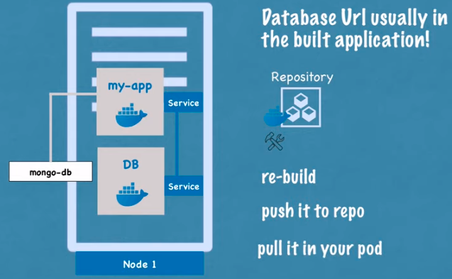

**ConfigMaps:**

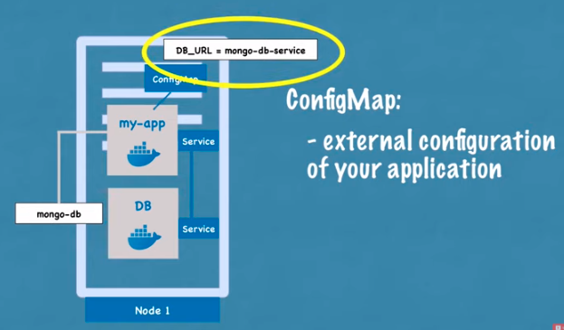

**Secrets:**

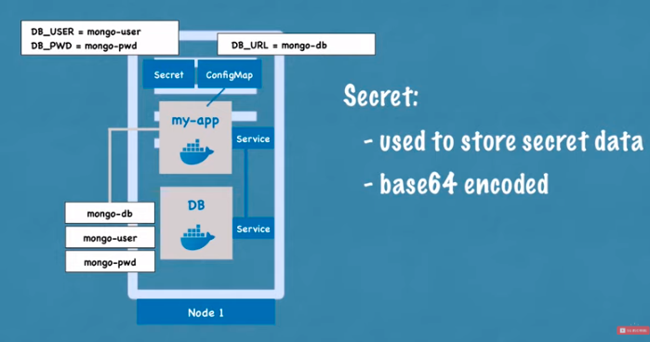

**Volume:**

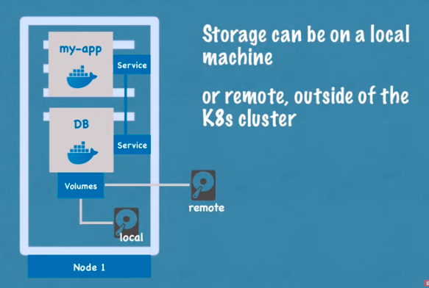

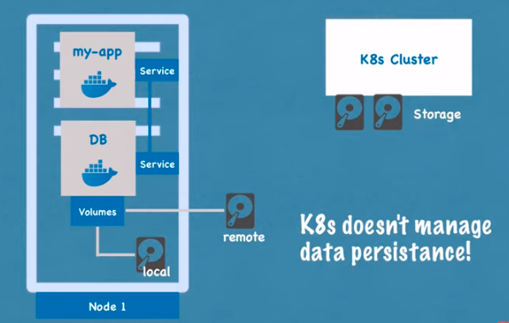

**Kubernetes YAML File: Deployment and Service**

**kubernetes-configuration-file-explained**

1. Meta Data
2. Specification
3. Status

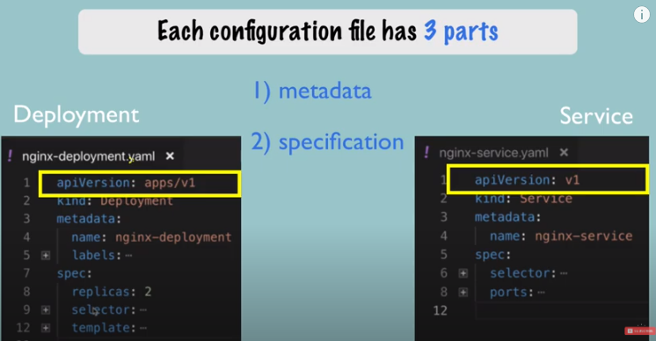

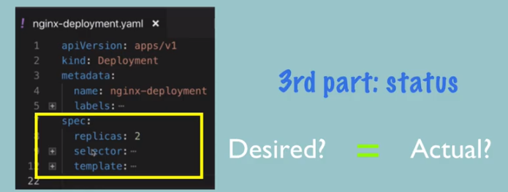

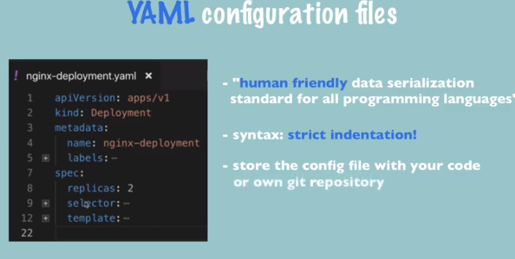

**Deployment**

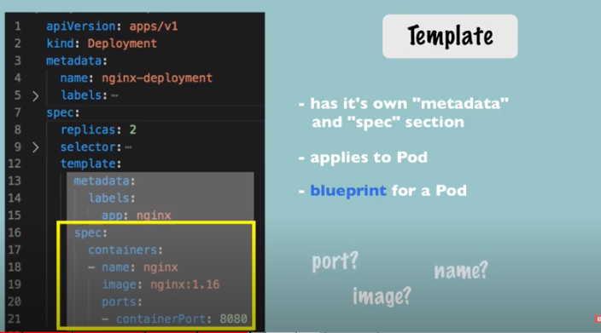

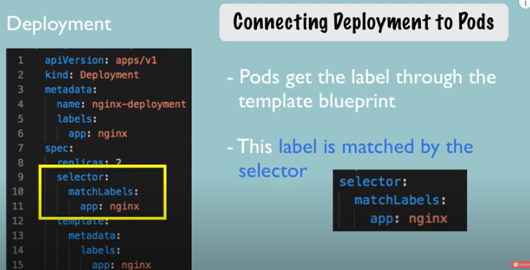

**Service:**

By using Service selector, can able to connect to the pod.

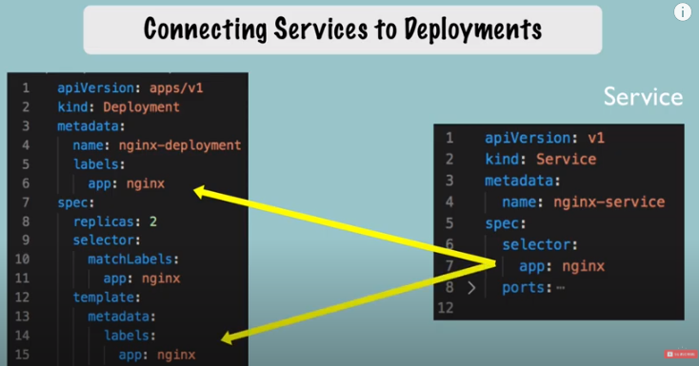

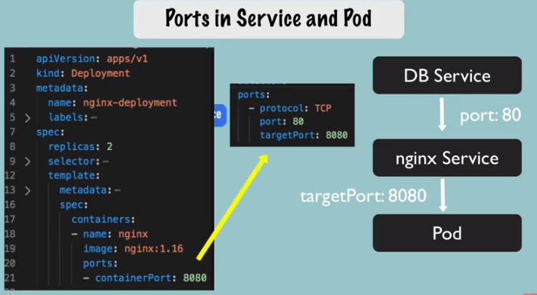

**Kubernetes Networking:**

**container-communication-k8s-networking**

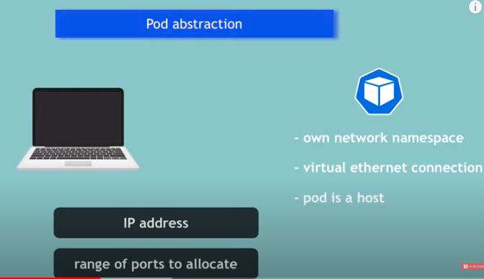

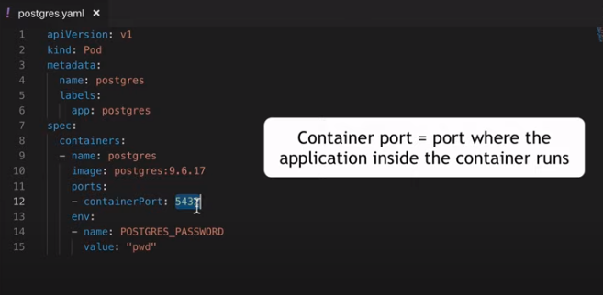

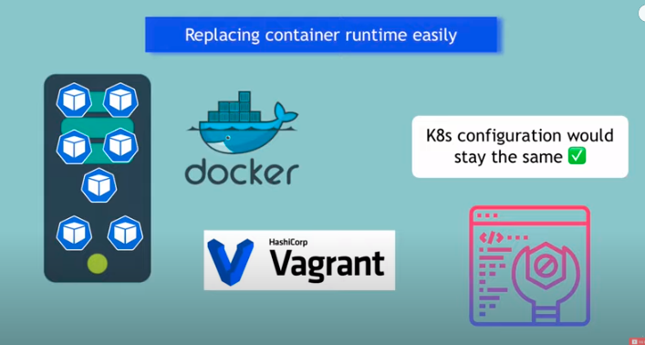

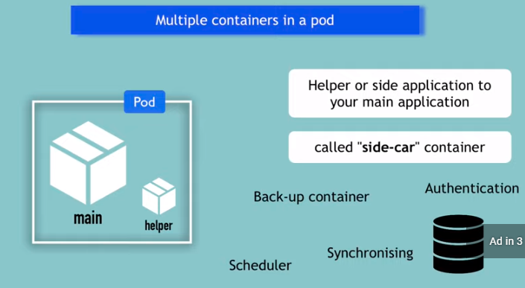

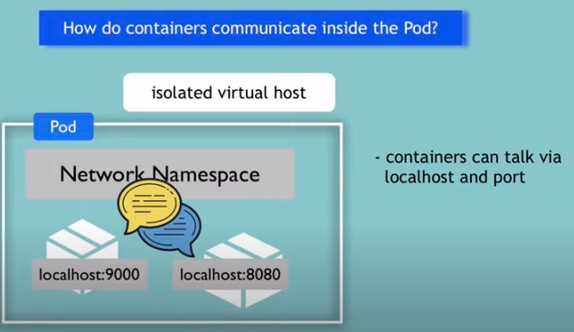

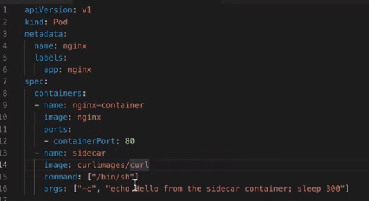

**Kubernetes ConfigMap and Secret as Kubernetes Volumes**

**configmap-and-secret-volumes**

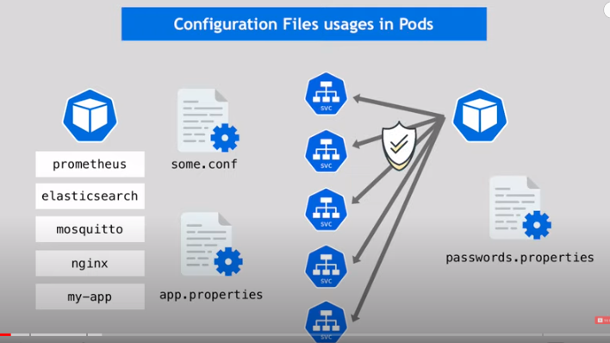

**Kubernetes Ingress**

**What is Kubernetes Ingress?**

Kubernetes Ingress is an API object that provides routing rules to manage external users' access to the services in a Kubernetes cluster, typically via HTTPS/HTTP.

With Ingress, you can easily set up rules for routing traffic without creating a bunch of Load Balancers or exposing each service on the node. This makes it the best option to use in production environments.

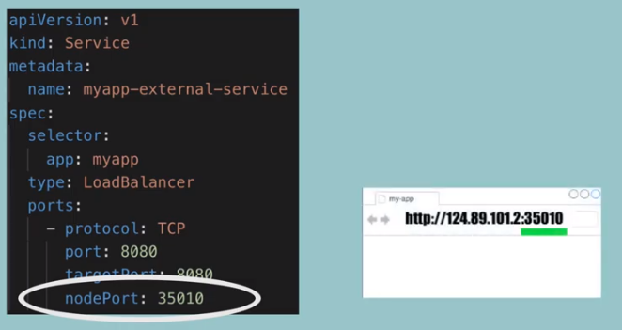

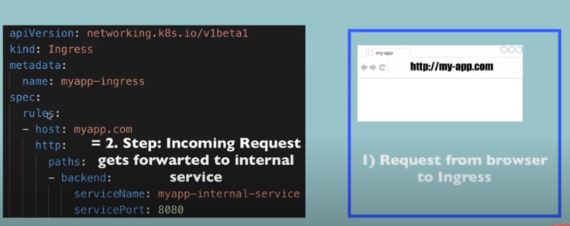

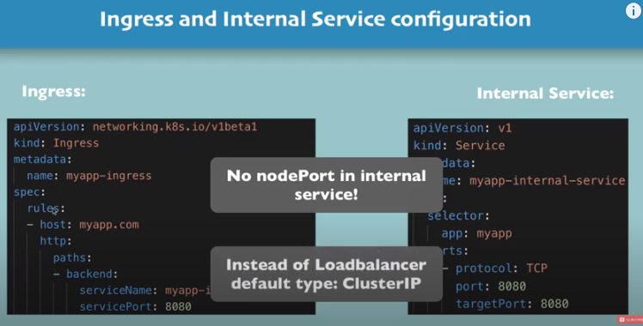

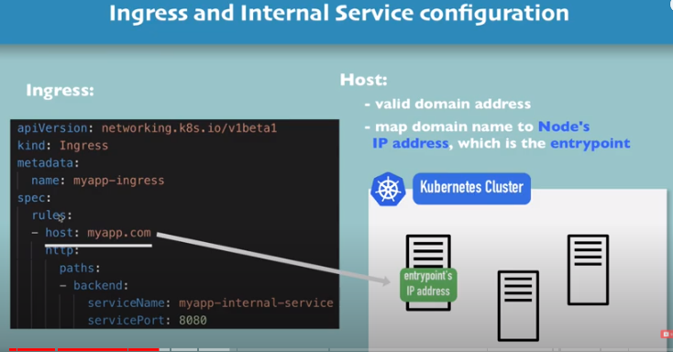

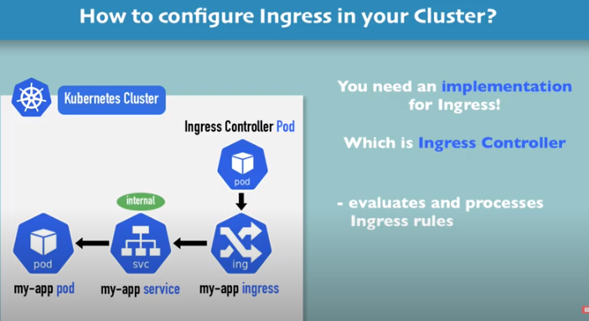

**What is Ingress Controller?**

If Kubernetes Ingress is the API object that provides routing rules to manage external access to services, Ingress Controller is the actual implementation of the Ingress API. The Ingress Controller is usually a load balancer for routing external traffic to your Kubernetes cluster and is responsible for L4-L7 Network Services.

- Evaluates all the rules

- Manages redirections

- Entry point to the cluster

- Many third party implementations

1) Kubernetes Nginx Ingress Controller

If I have 50 rules or 50 ingresses are available in my cluster, it will evaluates and forwards request to particular ingress.

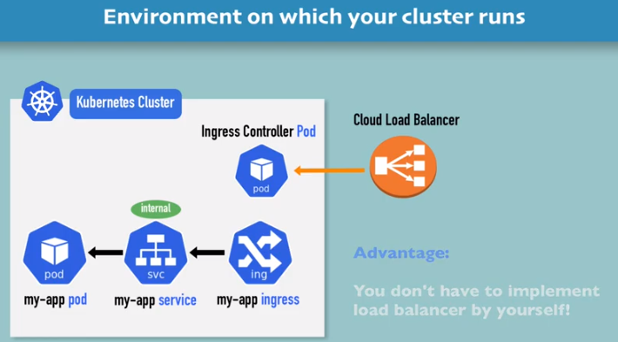

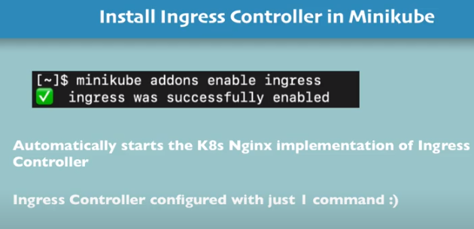

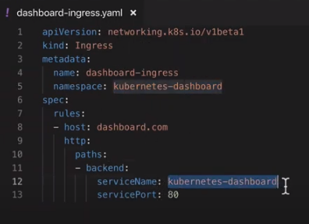

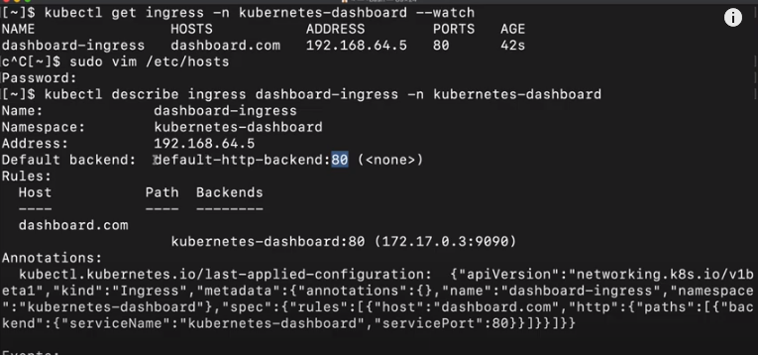

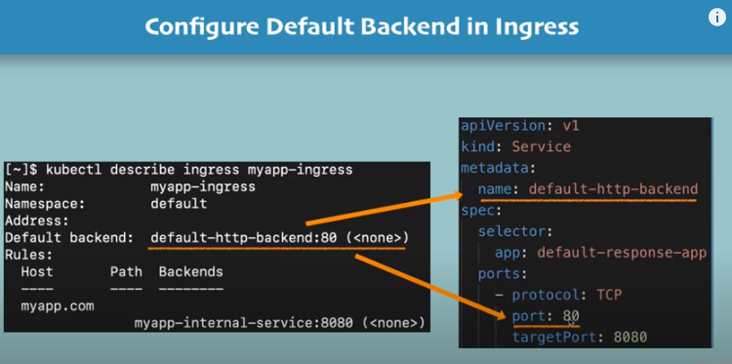

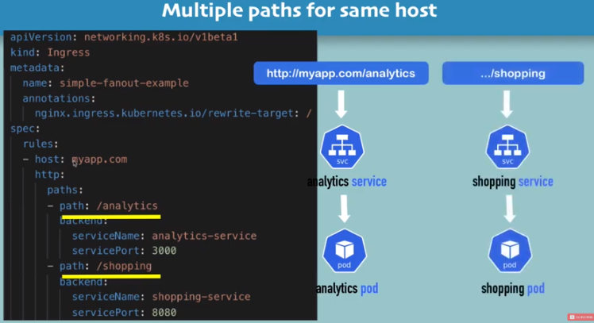

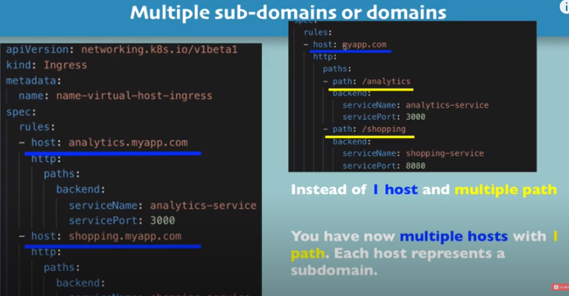

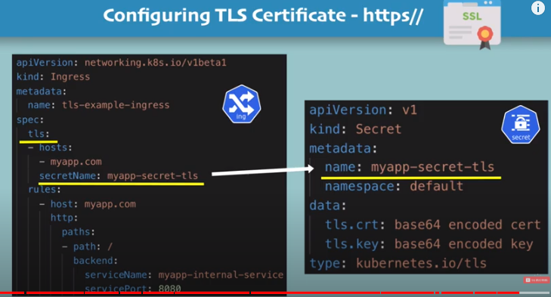

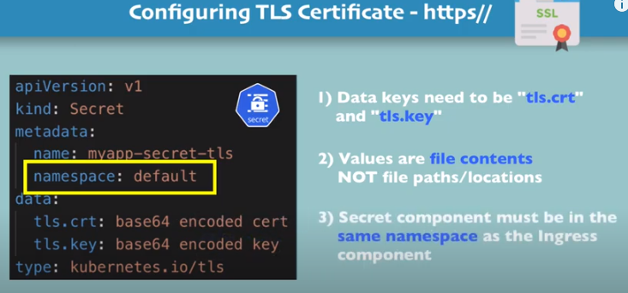

**Explanation of Kubernetes Volumes**

**File: kubernetes-volumes**

**Volumes**

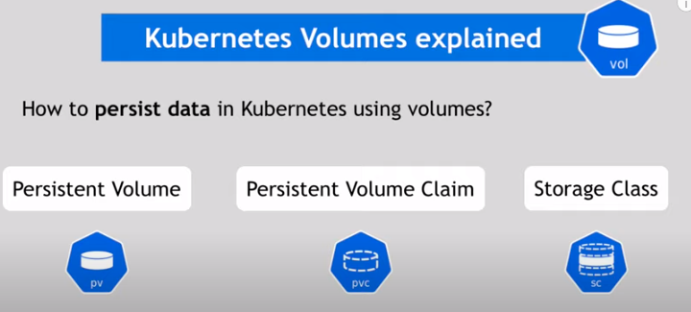

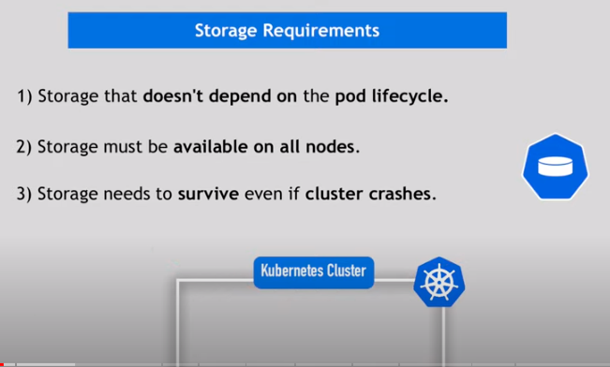

Database is a Directory. It contains application files and config files etc..

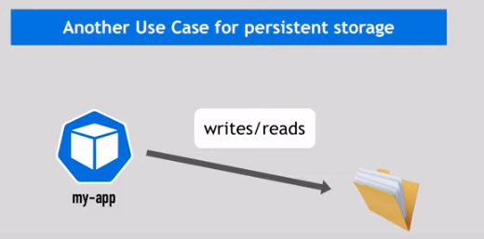

Persistence volume a any of the resource creates by using persistence volumes. It contains the usage of RAM, CPU and storage requirements. Persistence volume is just a interface. It is just a abstraction, it will takes the actual storage from the Kubernetes cluster local disk, nfs server, Cloud storage.

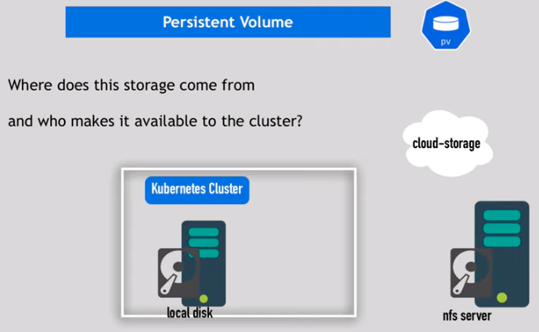



Your Kubernetes cluster uses a multiple storages.

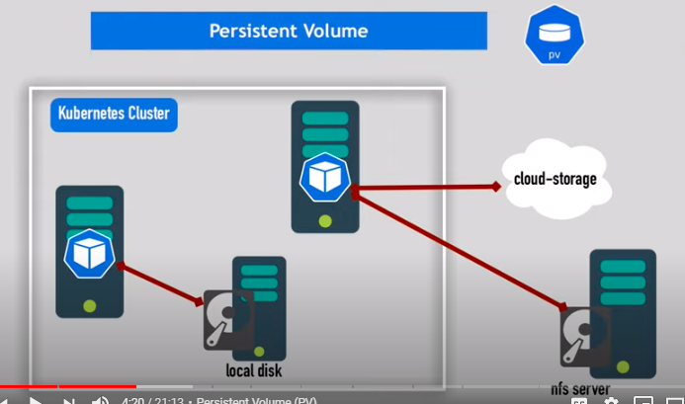

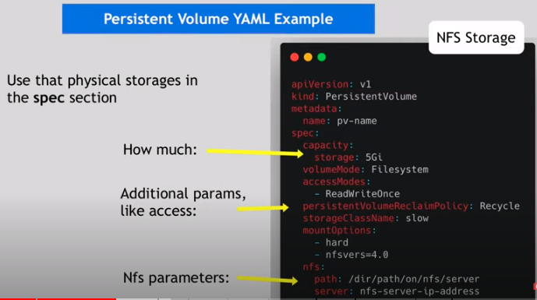

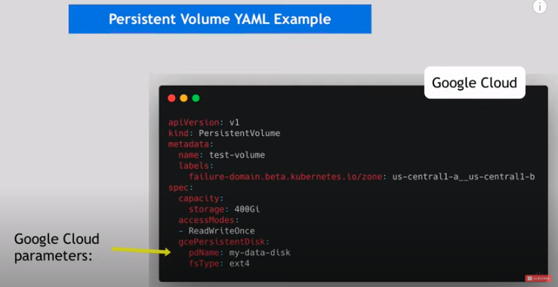

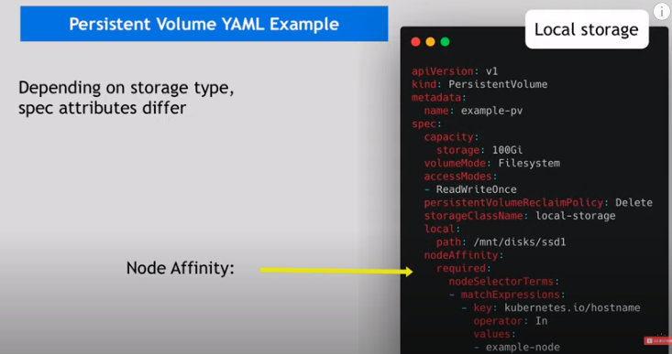

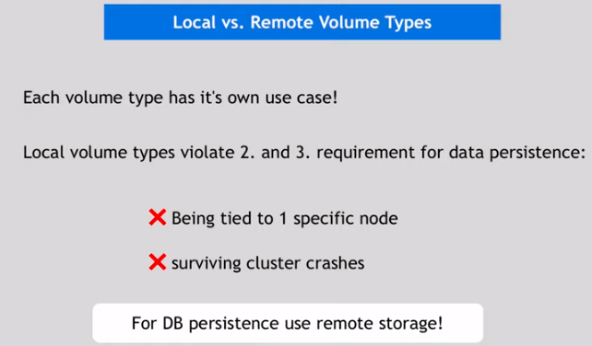

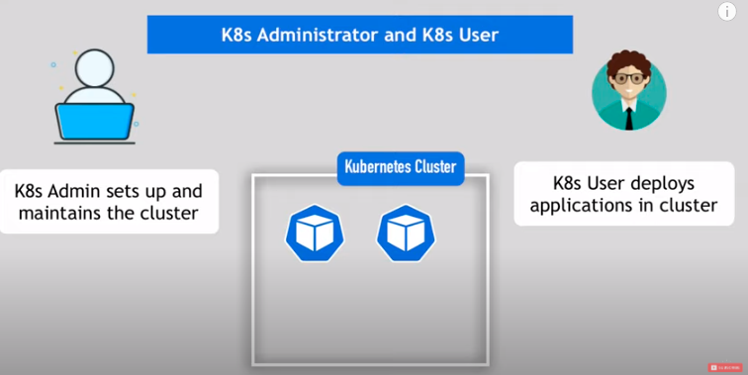

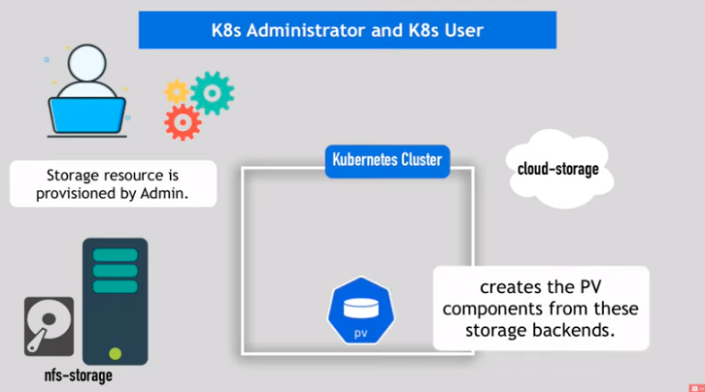

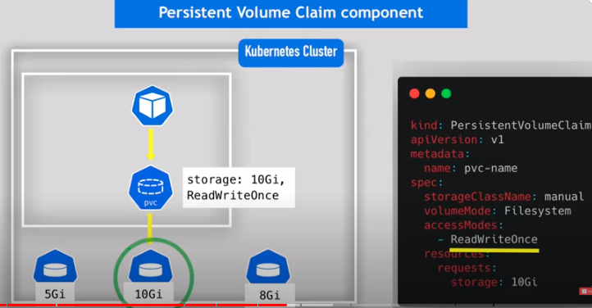

Persistence volume must be in same namespace

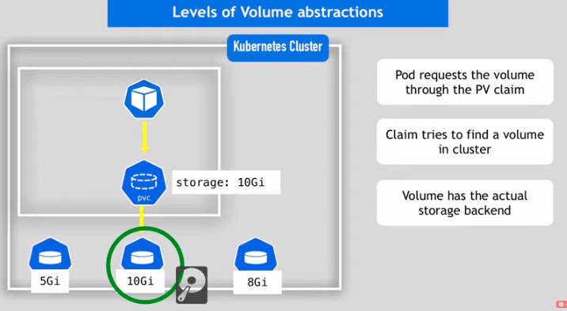

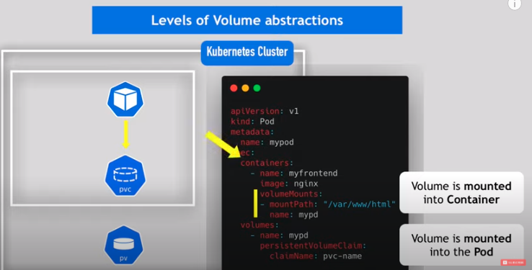

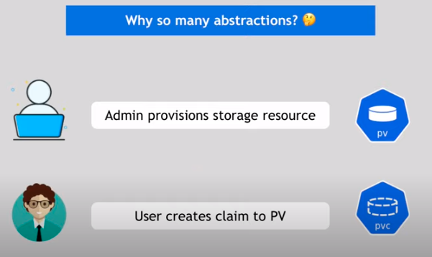

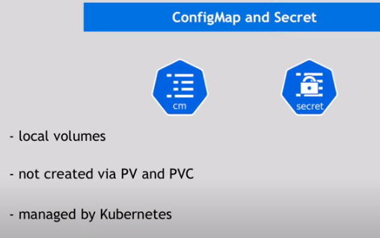

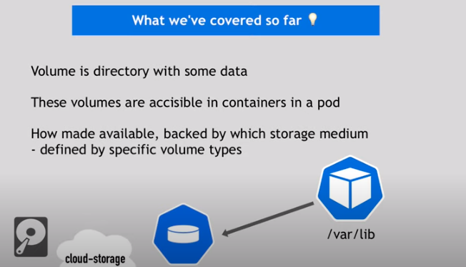

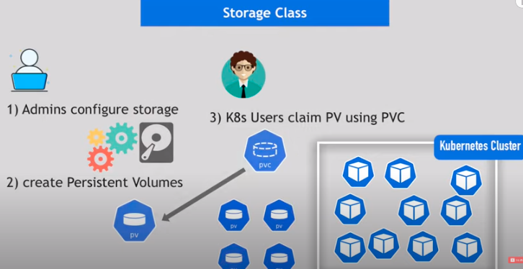

Storage class creates PV dynamically in the background

